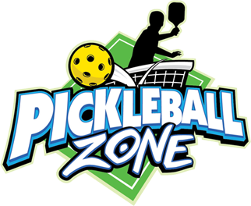 PICKLEBALL
Pickleball is a racquet sport invented in 1965. It combines elements of badminton, tennis and
ping-pong. The game is played with a hard paddle and a whiffle type ball. It can be played as single and doubles. The red lines on the tennis courts 3 and 4 are Pickleball lines.
SERVING
- The ball is served underhand starting from the right hand side of court behind the base line and is served diagonally to the opponents’ service zone.
- Each player must play the first shot off of the bounce. After the ball has bounced once on each side, then both players can volley the ball in the air or play it off the bounce. It is called the double bounce rule because the ball must hit once on each side before it can be volleyed.
- The server continues to serve, alternating service courts, until the server faults.
VOLLEYING
- To volley a ball means to hit it in the air without first letting it bounce.
- The non-volley zone also known as the kitchen is the 7 foot zone from both sides of the net. No volleying is permitted within the non-volley zone.
- When volleying the ball, the player may not step on or cross over the line.
- If the ball is hit into the non-volley zone, it must bounce before you return the hit.
SCORING
- Points are scored by the serving side only and occur when the opponent faults (fails to return the ball, hits the balls out of bounds, etc...)
- The first side scoring eleven points and leading by at least two points wins.

