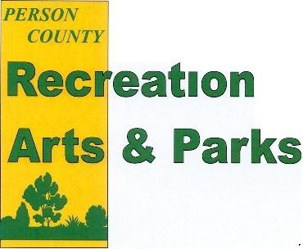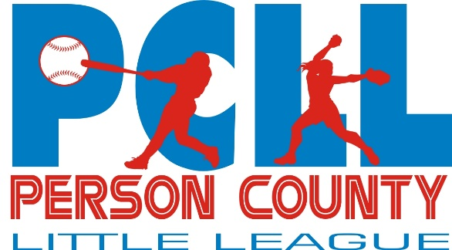

Person County Little League Spring Ball Sign-ups

The Person County Recreation, Arts, and Parks Department and Person County Little League Board will be having individual registration for Little League Spring Ball January 1st through February 3rd, 2023.

League Age Age Cut-off Playing Nights Fee
Pre T-Coach 4 August 31st, 2023 Tuesday/Friday $55.00
T-Coach 5-6 August 31st, 2023 Monday/Thursday $65.00
Coach Pitch Softball 7-8 January 1st, 2023 Tuesday/Friday $65.00
Coach Pitch Baseball 7-8 August 31st, 2023 Tuesday/Friday $65.00
Minor Softball 9-11 January 1st, 2023 Monday/Thursday $65.00
Minor Baseball 9-10 August 31st, 2023 Monday/Thursday $65.00
Minor Baseball 11-12 August 31st, 2023 Tuesday/Friday $65.00

In order to play Pre T-Coach youth must be 4 on or before August 31st, 2023.

Please note that all age groups are offered in boys and girls with the exception of the 4 year old group. Should there not be enough players for each group the Recreation Department will contact you and you will receive a refund.

Deadline to register will be Friday, February 3rd, 2023.

The season is scheduled to start the week of March 20th with opening ceremonies on March 25th.

Skills Day: February 4th – Location and time will depend on the weather. Information will be sent to players via email and posted on social media. All players 8U and up will be required to attend skills day regardless of if they played last year. A blind draft format will be used with no returning teams.

For more information, please call the Recreation Department at 336-597-1755. Parents are encouraged to register their child with the on-line registration at www.personcountync.gov (Go to Government, Recreation, Arts & Parks, Online Registration)

Person County Recreation, Arts, and Parks and Person County Little League is on Facebook. Please become a fan to receive updates on all programs!

There is a Q&A on-line at www.personcountync.gov and on the Person County Little League Facebook page. The Q&A has a lot of information available to the public regarding the league. The rules of the league are also available on the website.

Please note that all Covid-19 North Carolina Governor Cooper, NCDHHS and CDC guidelines will be followed. These guidelines are subject to change at any point which could result in program changes or termination.

